**Website Design**

We develop a website that represents you in the online world, among thousands of other companies. What makes you unique in the digital world will be based on your website, this is why it’s so vital to take this with special consideration and present your website by the best standards, ensuring to stay in the lead of your competitors in Lagos & around the world. We understand that at the end of the day, your business website needs to give you a return on your investment in order to be worthwhile.

We assure you that our web developer will work on each step of the web development process, and our valuable knowledge that we have gained throughout the years will help you grow. In the absence of a website, you are drastically limiting the reach of potential customers, neither can they get access to your products online. Our web experts are able to deliver high-quality, user-friendly, and modern websites in the promised deadline.

We specialize in offering corporate website development, portfolio design, wordpress development, landing page development and website maintenance. If you want to unleash the presence of your business online, get in touch. We go the extra mile to deliver what you have been expecting.

**Design a Website**

We strive to make companies shine by adopting high-quality designs in its portfolio. We are skilled at creating designs that draw attention, turn heads, and leave you speechless with their immense elegance and grace. The procedure for creating designs is simple.

**Simple and hassle-free**

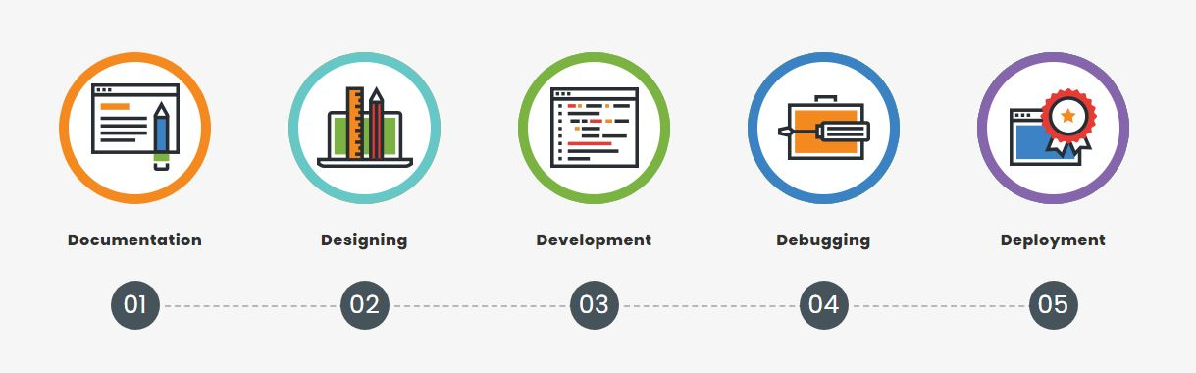

**Note:- Check url**: <https://www.brandsdesign.com/web-design>

**Web Design Packages**

We believe in providing affordable web design services to all. For this very purpose, we have designed some web design packages.

**SME Professional**

**Design + Print**

**N140,000**

**Features**

- 5 Page Static Website

- Mobile Responsive Layout

- JQeury Slider Banner

- Gallery Page

- Social Media Integration

- Contact us Page

- Website Favicon Design

- 6GB Hosting Webspace

- Product/Service Page

**Delivery**

14 Working Days

**SME Corporate**

**5 Page**

**N120,000**

**Features**

- 5 Page Static Website

- Mobile Responsive Layout

- JQeury Slider Banner

- Gallery Page

- Social Media Integration

- Contact us Page

- Website Favicon Design

- 6GB Hosting Webspace

- Product/Service Page

**Delivery**

14 Working Days

**SME Kickstart**

**Single Page**

**N80,000**

**Features**

- 1 Page Static Website

- Mobile Responsive Layout

- JQeury Slider Banner

- Gallery Section

- Social Media Integration

- Contact Us Section

- Website Favicon Design

- 1GB Hosting Webspace

**Delivery**

7 Working Days

ORDER NOW

ORDER NOW

ORDER NOW

**Got Questions? We Can Help**

**How many pages do I need for my website?**

Most basic websites can be built in 5 pages or less. Some websites can even be built on a single page.

Advanced websites and websites that sell products or services generally have a lot more pages.

If you’re unsure of how many pages you need, you can give us a call. We’ll understand what you’re trying to accomplish, research competitors, and then suggest a Site Map (number of pages and titles) for you to approve.

**Can you build mobile-friendly websites?**

If you’re looking for web design services that build mobile-friendly websites, then look no further. We can cater to your need by building high-quality web designs that are responsive, and functional on every digital device.

**Does your management include managing my contents?**

No. We do not manage or create clients’ contents except on a special arrangement which may attract additional fee

**When can I expect to have my completed package?**

Each package is listed with its delivery timeframe. We run strict processes to be able to meet these deadlines. It’s important that you’re across the timeline so we can incorporate your feedback into our work. When we work together, we can finish the project sooner than later.

**Are there hidden charges to your services?**

No, not at all! The prices we list on our website are all there is to the price except you want to upgrade a service or renew services that are on subscription.

**Can I manage my website?**

If your website is CMS, you can definitely manage, edit and delete your website pages using a user-friendly interface.

**When will I get the copyrights of my website?**

Once the development is created, we deliver a complete website to you and transfer the copyrights.

**What am I supposed to do? What would be my role during the entire process?**

You can rely on us for completing your work on promised deadlines and we expect the same timeliness from our clients. If a client does not get back to us within 20 days, we reserve the right to cancel the project at client’s expense. We understand that some major thinking and decision making is involved in making branding decisions however you can ask us for more time but in the event of client being non-responsive, we will stop the project after the advised time period has passed.

**Ready to improve your online presence?**

GET IN TOUCH